- Dr. Wittgenstein is researching the time it takes people to fall asleep at night. In his lab, he records the time it takes each of his subjects to fall asleep, in minutes, and compiles the data set shown below.

$$\left\{22, 8, 19, 14, 25, 95, 32, 7, 14, 20, 18, 10, 22, 17, 27, 16\right\}$$

Identify the following:

Min: ________ $Q_{1}:$________ Median: ________ Mean: ________ $Q_{3}:$________ Max: ________

IQR: ________ Range: ________

- Senior and freshman year amount of time spent on homework was compared in minutes and the results displayed in the boxplot below.
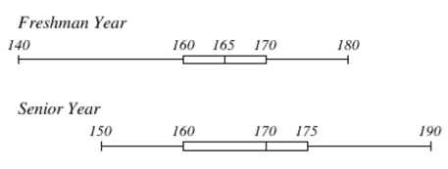

- For the Freshman, what percentage of freshman spent between 160 and 170 minutes on homework? __________
- For the Freshman, 25% of the data is below what value? __________
- For the Seniors, what is the range of the data? __________
- Which year (Senior or Freshman) represents 50%of the data that is 165 minutes or less? __________
- What value for Seniors represents 75% of less of the data? __________

- Team A and Team B scored points and were compared using a box plot.
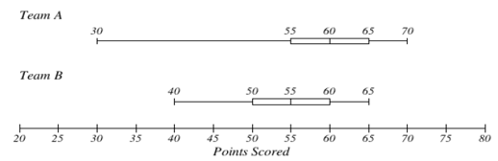
Compare the maximum values, and then identify who had the higher maximum.

Team A Max: _________ Team B Max: _________
- The data below are the last 6 Unit Test Scores:
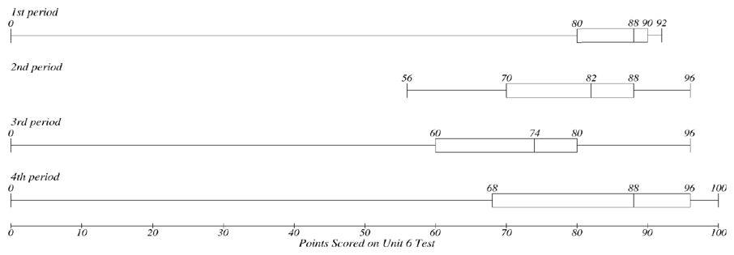

- Which class had the lowest $Q_{3}$? ____________________
- Which class had the highest IQR? ____________________
- Which class had the highest minimum value? ____________________

- Find the mode for the data set.
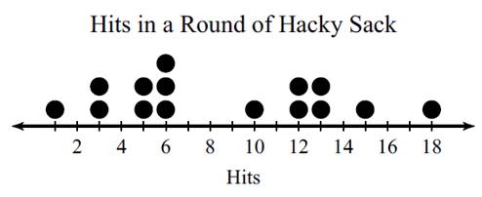
A) 4 B) 5 and 8 C) 6 D) 13

- Consider the following ordered data set.

$$\left\{2, 3, 5, 7, 7, 9, 10\right\}$$

Which is the correct box and whisker plot of the data above?

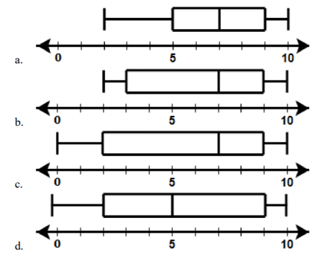
Use the below dot plot to answer the following questions:

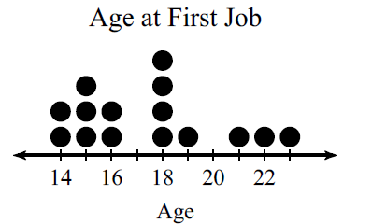

- What is the mean of the above dot plot? __________
- What is the center of the above dot plot? __________
- What is the spread of the above dot plot? __________
- How many people are represented on the above dot plot? __________
- How many people were at least 18 when they started their first job? __________

