Choose the correct answer.

- Sharice is trying to restart her New Year’s resolution so she investigates the costs of gyms near her. She determines LA Fitness to be the best option. The sign-up fee at LA Fitness is $75, and costs $30 a month after that. After six months, how much money has Sharice spent towards the gym?

- $255 B. $330 C. $480 D. $362

- A new sports car sells for $35,000. The value of the car depreciates 18% annually. Which of the following choices models the yearly value of the car since its purchase?

- $y=35000∙{0.82}^{x}$ B. $y=35000∙{1.18}^{x}$
C. $y=35000∙{0.18}^{x}$ D. $y=35000∙{1.018}^{x}$

- At the end of last year, the population of Alaina’s hometown was approximately 75,000 people. The population is growing at the rate of 2.4% each year. Which function models the growth of this town?

- $f\left(x\right)=75000∙{0.976}^{x}$ B. $f\left(x\right)=75000∙{1.024}^{x}$
C. $f\left(x\right)=75000∙{0.76}^{x}$ D. $f\left(x\right)=75000∙{1.24}^{x}$

Using the equation of the exponential function given, answer the following questions:
$$y=-\frac{3}{2}∙4^{x-2}-1$$

- What is the asymptote of this function? 5. How does the function move horizontally?

6. Is this function a reflection? How do you know? 7. How does this function move vertically?

8. Is this function stretched or compressed?

Using the equation of the exponential function given, answer the following questions:
$$y=3∙{\left(\frac{1}{4}\right)}^{x-1}+3$$

9. What type of exponential function is given above? Growth or decay and why?

10. How does this function shift vertically? 11. Does this function stretch or compress, and by what factor?

12. How does this function move horizontally? 13. Is this function a reflection? Why or why not?

14. Given the function $y=2^{x}$, what transformation produces the new function $y=2^{x+3}$?

- Vertical shift up 3 B. horizontal shift right 3
C. Vertical stretch by a factor of 3 D. horizontal shift left 3

Geometric sequences are created by multiplying the prior term by a constant value, called the common ratio. This common multiplication occurring can be viewed as a “growth factor,” similar to what we see in exponential growth.

15. Given: 3, 9, 27, 81, …
Which function models this sequence?

- $y=3^{x}$ B. $y=3{(1-0.3)}^{x}$ C. $y=3{(1+0.3)}^{x}$ D. $y=x^{3}$

Given the equation $y=20∙{0.9}^{x}$

16. Does this equation represent exponential 17. What is the initial value?
growth or decay?

- Exponential decay
- Exponential growth

17. What is the rate?

400 students are chosen for a game. 15% are randomly cut each day.

19. This is a situation of: 20. How can you write a function that models the
game?
- Exponential growth
- Exponential decay

Freeze tag is being played in elementary school. The person who is “it” tags 35% more people each round. First, there are 2 people to start.

21. This is an example of: 22. How can you write a function that models this
game?
- Exponential growth
- Exponential decay

23. How many students will be frozen after 12 rounds?

Choose the correct equation and identify the domain and range for each.
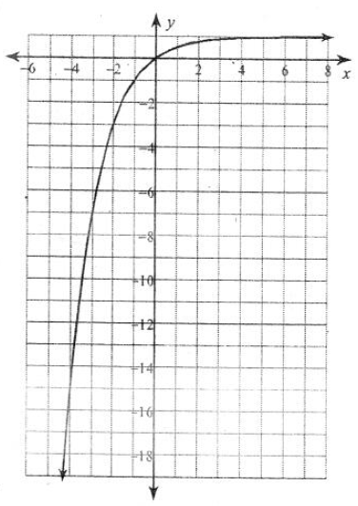
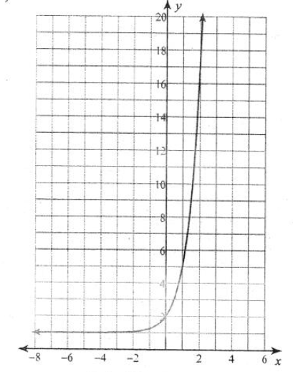
24. 25.

A. $y=4∙{\left(\frac{1}{4}\right)}^{x+1}+1$ A. $y=\frac{1}{3}∙{\left(\frac{1}{3}\right)}^{x-2}+2$
B. $y=\frac{1}{4}∙4^{x+1}+1$ B. $y=\frac{1}{3}∙{\left(\frac{1}{3}\right)}^{x+2}-2$
C. $y=-3∙2^{x-2}+2$ C. $y=5∙{\left(\frac{1}{2}\right)}^{x+1}-1$
D. $y=-4∙2^{x+1}+2$ D. $y=-\frac{1}{2}∙{\left(\frac{1}{2}\right)}^{x-1}+1$

