Directions: Draw the box and whisker plot and give the five-number summary for each data set.
1. The number of days each month that Mr. Wilkerson gave homework to his students:  $$\left\{12, 18, 15, 10, 20, 16, 22, 14, 9, 5\right\}$$  0 2 4 6 8 10 12 14 16 18 20 22 24 26 28 30 | Minimum: ______  Lower Quartile: ______  Median: ______  Upper Quartile: ______  Maximum: ______
2. The number of electoral votes won by the republican candidate in presidential elections from 1960 – 2016:  $$\left\{306, 206, 173, 286, 271, 159, 168, 426, 525, 489, 240, 520, 301, 52, 219\right\}$$  0 40 80 120 160 200 240 280 320 360 400 440 480 520 560 600 | Minimum: ______  Lower Quartile: ______  Median: ______  Upper Quartile: ______  Maximum: ______
3. The number of calories in each sandwich listed on the menu at a fast food restaurant:  $$\left\{320, 420, 580, 270, 320, 380, 360, 270, 320, 310, 440, 470\right\}$$  200 230 260 290 320 350 380 410 440 470 500 530 560 590 620 650 | Minimum: ______  Lower Quartile: ______  Median: ______  Upper Quartile: ______  Maximum: ______
4. The speed, in miles per hour, of the first 20 pitches thrown in a baseball game:  $$\left\{66, 74, 80, 70, 72, 74, 63, 82, 72, 78, 75, 84, 73, 65, 76, 80, 65, 81, 73, 78\right\}$$  60 62 64 66 68 70 72 74 76 78 80 82 84 86 88 90 | Minimum: ______  Lower Quartile: ______  Median: ______  Upper Quartile: ______  Maximum: ______

Directions: Use the box and whisker plot to answer the questions.
5. The box and whisker plot below shows the ages of the 36 players on the 2016-2017 Buffalo Sabres hockey team.  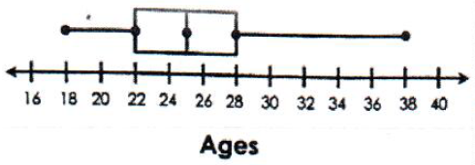 | a) What is the interquartile range?
 | b) About what percent of the players are at least 25 years old?
 | c) About how many players are no more than 28 years old?
6. The box and whisker plot below shows the peak wind speeds, in miles per hour, for each of the 15 named storms that formed in the North Atlantic in 2016.  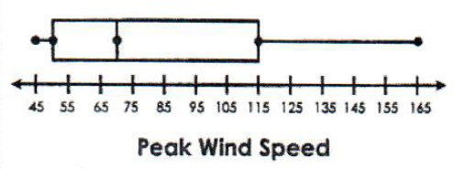 | a) About what percent of the storms had a wind speed between 70 and 115 mph?
 | b) About how many storms had a wind speed of at least 50 mph?
 | c) If Hurricane Nicole had a peak wind speed of 115 mph, what can you conclude?
7. Mr. Whitman gave a test to his 32 math students. He felt the results were low, so he retested them one week late. The results of the original and retake test are shown below.  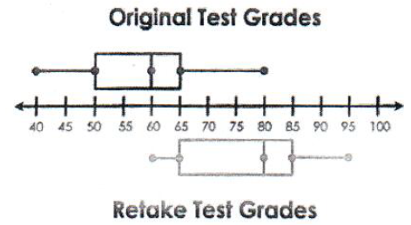 | a) What is the difference in the median grade?
 | b) Compare the percent of students who got at least a 60 on the original test to those that got at least a 60 on the retake.
 | c) If students need a 65 in order to pass the test, how many more passed the retake?

