Main Ideas/Questions | Notes/Examples
Box and Whisker Plot | A graphic format used to display the median, quartiles, and extremes of a data set on a number line that shows the distribution of the data  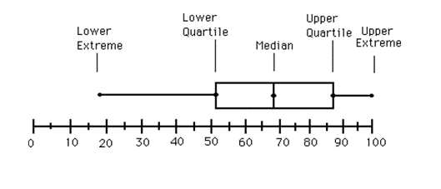
Five-Number Summary | The values used to create the box and whisker plot:  - Minimum value: the smallest value in the data set  - Lower Quartile ($Q_{1})$: median of the lower half of the data set  - Median: the value in the middle when the data is ordered from least to greatest  - Upper Quartile ($Q_{3}$): median of the upper half of the data set  - Maximum Value: the largest value in the data set
Quartiles | - $Q_{1}$- lower quartile is the left edge of the box  - $Q_{3}$ – upper quartile is the right edge of the box
Interquartile Range | - upper quartile – lower quartile OR $Q_{3}-Q_{1}$  - $Q_{1}$ to $Q_{3}$ (box) represents 50% of the data set
Drawing Box and Whisker Plots | 1. The resting heart rates, in beats per minute (bpm), of a group of people are given below. Find the five-number summary, draw the box and whisker plot, and then answer the questions that follow.
 | $$\left\{55, 72, 64, 58, 50, 62, 70, 84, 92, 76, 68, 60\right\}$$ |  | Minimum: ______  Lower Quartile: ______  Median: ______  Upper Quartile: ______  Maximum: ______
 | a) What is the range? | b) What is the interquartile range?
 | c) What percent has a resting heart rate less than 66 bpm? | d) What percent have a resting heart rate of no more than 74 bpm?
 | e) What percent have a resting heart rate between 50 and 59 bpm? | f) What percent has a resting heart rate between 66 and 92 bpm?

Drawing Box and Whisker Plots (continued) | Directions: Draw the box and whisker plot and give the five-number summary for each data set.
 | 2. Number of games won by the Detroit Lions in their last 10 seasons:  $$\left\{9, 7, 11, 7, 4, 10, 6, 2, 0, 7\right\}$$ |  | Minimum: ______  Lower Quartile: ______  Median: ______  Upper Quartile: ______  Maximum: ______
 | 3. The speed of 9 cars on the highway:  $$\left\{62, 77, 80, 54, 65, 67, 58, 63, 70\right\}$$ |  | Minimum: ______  Lower Quartile: ______  Median: ______  Upper Quartile: ______  Maximum: ______
 | 4. The high temperature in the last 15 days:  $$\left\{58, 67, 80, 72, 69, 59, 59, 75, 83, 84, 84, 76, 64, 64, 71\right\}$$ |  | Minimum: ______  Lower Quartile: ______  Median: ______  Upper Quartile: ______  Maximum: ______
Analyzing Box and Whisker Plots | 5. The box and whisker plot below shows the test scores for a group of 24 students.  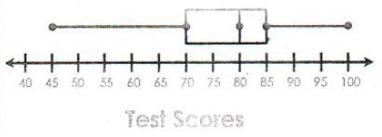 | a) What is the median score?
 |  | b) What percent of the students scored between 70 and 85?
 |  | c) How many students scored between 45 and 85?
 | d) If Kate got an 87, how did she do compared to the class?

Analyzing Box and Whisker Plots (continued) | 6. The fuel efficiency, in miles per gallon (mpg), of a group of cars is shown below.  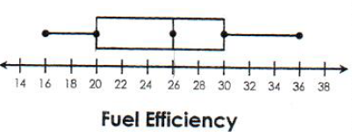 | a) What is the interquartile range?
 |  | b) What percent of the cars have a fuel efficiency greater than 20 mpg?
 |  | c) What percent of the cars have a fuel efficiency less than 26 mpg?
 | 7. The battery life, in hours, of a group of 16 laptops is shown below.  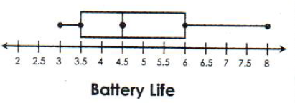 | a) Identify the lower and upper quartiles.
 |  | b) What percent of the laptops have a battery life of at least 6 hours?
 |  | c) How many laptops have a battery life less than 4.5 hours?
 | 8. Fifty golfers are competing in a golf tournament. The scores in the first round are shown below.  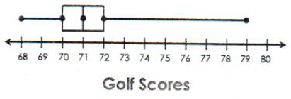 | a) Identify the minimum and the maximum values.
 |  | b) What percent of the golfers had a score greater than 70?
 |  | c) In order to advance to the next round, golfers cannot score above 72. How many are not moving on?
Comparing Box and Whisker Plots | 9. Mr. Athens and Mrs. Gillman gave the same test to their math classes. The scores of each class are shown below.  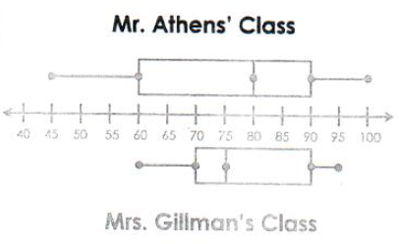 | a) What is the difference in the median score?
 |  | b) Which class has the greater range of scores?
 |  | c) Which class do you feel did better overall? Explain.

