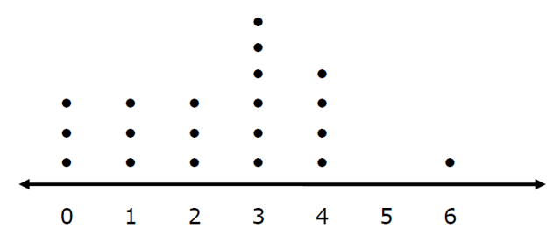
1. The students in one Social Studies class were asked how many brothers and sisters (siblings) they each have. The dot plot here shows the results:

- How many of the students have 6 siblings? ______

- How many of the students have no siblings? ______

- How many of the students have three or more siblings? ______

2. The resting pulse rates were recorded for 16 boys in gym class before they exercised. The dot plot here shows the results:
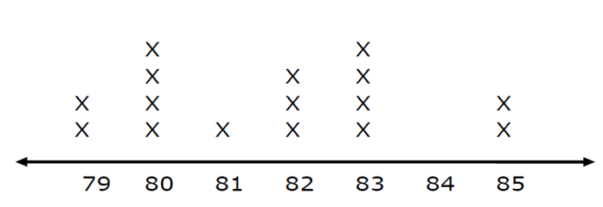

- What is the range of the pulse rates? ______
- How many boys had a pulse rate over 81? ______
- How many boys had a pulse rate of 83? ______
- How many boys had a pulse rate of at most 82? ______

3. A manufacturer records the number of errors each workstation makes during the week. The data are as follows:
$$\left\{6, 3, 2, 3, 4, 5, 2, 0, 2, 5, 4, 0, 1\right\}$$

Which of the following is an accurate dot plot of the data collected?
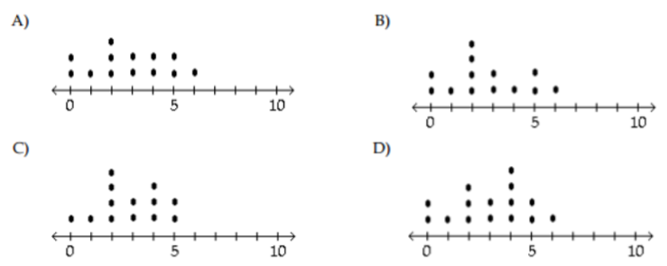

4. Four girls on a high school track and field team practice the shot put. Each girl made 10 attempts, and the distances measured after each attempt are shown on the plots below.
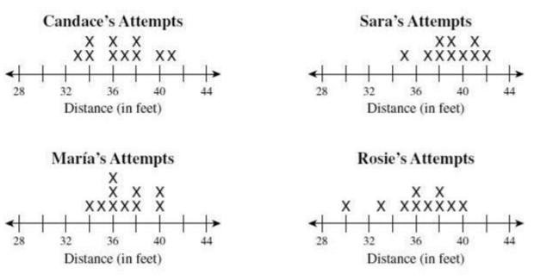

- Which girl’s range of distance was the greatest? ______________

- What was Maria’s mode? ______

- Which girl did not have a median of 36.5? ______________

5. Find the following values for the dot plot below:
Range: ___________ Median: ___________ Mode: ___________
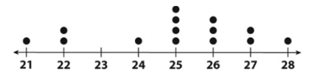

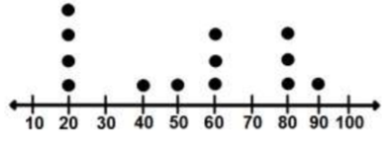
6. The dot plot represents the student scores on a math test:

- How many students took the test? ______

- What is the median score? ______

- How many students scored at least a 60 on the test? ______

7. How many kids read 3, 4, and 5 books based on the dot plot below? ______
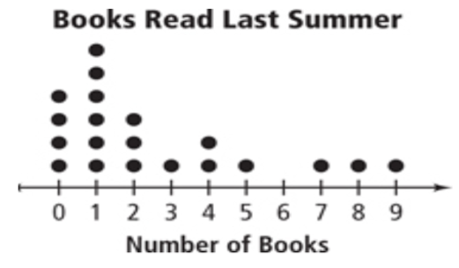

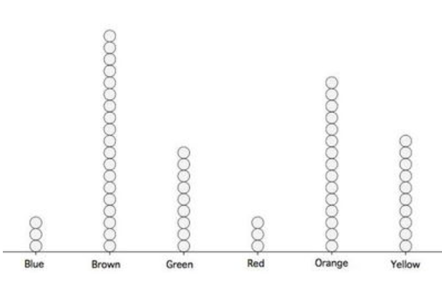
8.

- Do more people like yellow or green? ______

- What is the difference? __________________________________________________________

