- Each dot represents a number in the data set.
- Center is the middle number. It is also known as the median. List the numbers in order from least to greatest.
- Spread is the range. It is found by largest number – smallest number.
Examples
1. The dot plots show the number of miles run per week for two different classes. Use the dot plots below to answer a – d.
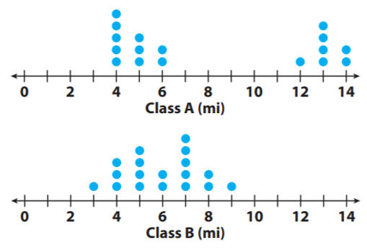

- Compare the centers of the dot plots.

Class A:
Class B:
______________________________________________________________________________

- Compare the spreads of the dot plots.

Class A:
Class B:
______________________________________________________________________________

- Calculate the medians of the dot plots.

Class A:
Class B:

- Calculate the ranges of the dot plots.

Class A:
Class B:
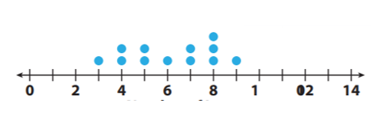
2. The dot plot shows the numbers of letters in the spellings of the 12 months. Use the dot plot to answer a – c.

0 2 4 6 8 10 12 14

- Describe the center of the dot plot: _________________________________________________

- Describe the spread of the dot plot: _________________________________________________

- Calculate the mean of the dot plot: _________________________________________________

3. The dot plots shows the number of pies contestant #1 – 10 ate. Use the dot plot to answer a – k.
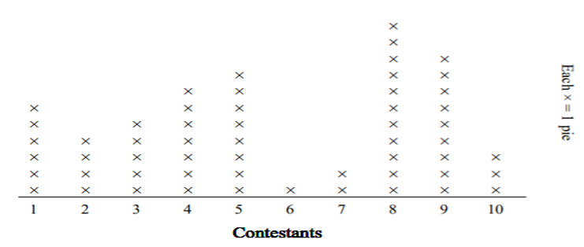

- How many pies did contestant 5 eat? ______
- Did contestant 2 or contestant 3 eat more pies? _________________________
- Did contestant 6 or contestant 4 eat fewer pies? _________________________
- How many contestants ate more than 3 pies? ______
- How many contestants ate fewer than 8 pies? ______
- What is the combined amount of pies that contestant 9 and contestant 8 ate? ______
- What contestant ate the most pies? ______
- Which contestant ate the fewest pies? ______
- Which contestants (if any) ate more than 8 pies? ______________________________________
- What is the difference in the number of pies contestant 3 ate and the number contestant 2 ate? ______

- Which contestant ate exactly 11 pies? _________________________

