Course Description
This is the second course in a sequence of courses designed to provide students with a rigorous program of study in mathematics. Algebra I will provide many opportunities to revisit and expand the understanding of foundational algebra concepts, will employ diagnostic means to offer focused interventions, and will incorporate varied instructional strategies to prepare students for required high school mathematics courses. The course will emphasize both algebra and numeracy in a variety of contexts including number sense, proportional reasoning, quantitative reasoning with functions, and solving equations and inequalities.
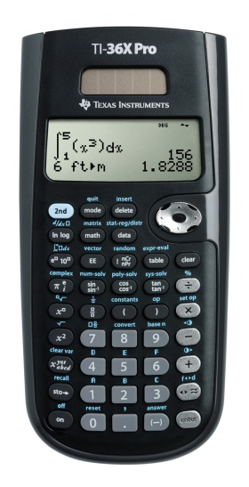
Recommended DAILY Materials
• 3-Ring Binder (or section of a binder), with 4 tabbed dividers
(labeled Warm Ups, Notes, Homework/Classwork, Quizzes)
• Pencils and Erasers, PLEASE no pens in math class!
• Lined Notebook Paper
• • Scientific Calculator…Students need to purchase a TI36XPRO calculator. These calculators cost around $20 and can be purchased at Office Max, Office Depot, Staples, or Amazon. Please try to purchase these as soon as possible as calculators are allowed almost daily in class. We have some calculators for students to use in class; however, students will need to have access to this calculator at home for the purpose of completing homework. We cannot allow students to take home our class set calculators. This calculator is allowed on standardized tests and can be used for Geometry and Algebra II. There is no need to purchase the expensive graphing calculators.
Greatly Appreciated
- Tissues
- Hand Sanitizer

Class Grading Percentages

Grading Scale Grading Percentages

90% - 100% A Homework 5%
80% - 89% B Quizzes 15%
75% - 79% C Unit Tests 55%
70% - 74% D Midterm 5%
69% or below F End of Course Test (EOC) 20%
Total 100%

Grading Policy
Homework/Classwork will be assigned daily and graded occasionally. Sometimes you will be given a homework quiz and it will be graded for accuracy. Other times, homework will be graded for completion. You will receive a grade percentage based on the number of problems completed. Writing down made up answers or answers only (with no work) will also result in a ZERO.

Late Work
Late work will not be accepted. You are expected to have assignments at the beginning of each class, if you do not have them, you receive a zero, NO EXCEPTIONS.

Homework Make-Ups
Homework may ONLY be made up if a student was absent the day an assignment/homework was given or collected for a grade. Otherwise, it is considered late, which is not accepted. Please see above. When a student is absent, it is his/her responsibility to pick up their missed materials from Mrs. Deuire. You may also check the class blog for any notes and/or assignments that were posted.

Assessment Make-ups
If a student only misses review day(s) before an assessment, the student is still responsible for taking the assessment on the assigned day as they have missed no new instruction because of the absence. If a student is absent the day an assessment is given, the student is responsible for scheduling a make-up time with the teacher outside of normal class hours. Class time will not be given for making up an assessment. The student must schedule the make-up session within a week. Make-up quizzes are not given. A zero will be entered into the gradebook and the corresponding test will replace the missing quiz grade.

Missing Assignment Policies
In Synergy, if you see a grade with an A next to it, it means that the assignment is missing and can be turned in based on the rules stated above. A grade of 0 means the assignment cannot be made up.

Class Expectations

Behavioral Expectations:
1. Be on time for every class (see tardy policy) in student agenda.
2. Respect teachers, other students, and their property.
3. Keep your area free of debris (clean up before leaving).
4. No electronics (cell-phones, tablets, etc.) unless allowed by the teacher.
5. Do not get up to leave class at the end of the period until dismissed by the teacher. Leaving class without permission could result in disciplinary actions.

Academic Expectations:
1. Be prepared with all necessary tools EVERY DAY! All materials should be out and ready to go when the bell rings.
2. Follow all directions.
3. Do your best work all the time!
4. Be Honorable – cheating will not be tolerated and will result in an automatic zero for the assigned activity, a call home, and a possible administrative referral.

Extra Help
Free math department tutoring is available after school on Tuesdays and Thursdays from 3:45- 4:45 pm. The specific room location will be posted in my classroom. Other sessions can be offered by appointment. PLEASE utilize these availabilities as soon as you need them!

Algebra I, Spring 2020
STUDENT NAME__________________________________________________ Block_____________
Please provide your e-mail address to help facilitate quick communication.
Parent email

Parent email #2

Parent Phone________________________________________
Parent Phone #2______________________________________
Please answer the following questions
- I have access to internet access at home YES NO

- I have access to a working printer at home YES NO

- I have access to Microsoft Word/ Powerpoint at home YES NO

Parent and student have read the syllabus and understand the requirements for this class. Both parent and student will check Synergy for grades and the website for assignment updates regularly especially when absent.

Student Signature_______________________________________________

Parent Signature________________________________________________

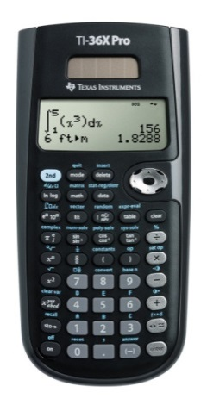
Please remember about the calculator for this class. TI-36X Pro! It is black with grey keys. They can be found at office supply stores (OfficeMax, Office Depot, Staples or on Amazon.com) and are approximately $20 - $25.

PLEASE RETURN THIS PAGE TO MRS. DEUIRE

